**Vowels**

|  |  |  |  |  |  |
| --- | --- | --- | --- | --- | --- |
| **Word** | **IPA Br. 1** | **IPA Br. 2** | **IPA Am.** | **Merriam** | **Description** |
| Sheep | ʃiːp | - | ʃip | ˈshēp | /ɪ/: short vowel  /i:/: long vowel  /eɪ/: diphthong  /aɪə/: triphthong |
| Ship | ʃɪp | - | - | ˈship |
| Pen | pɛn | - | - | ˈpen |
| Man | mæn | - | - | ˈman |
| Cup | kʌp | - | - | ˈkəp |
| Heart | hɑːt | hɑː(r)t | hɑrt | ˈhärt |
| Clock | klɒk | - | klɑk | ˈkläk |
| Ball | bɔːl | - | bɔl | ˈbȯl |
| Book | bʊk | - | - | ˈbu̇k |
| Boot | buːt | - | but | ˈbüt |
| Girl | gɜːl | gɜː(r)l | gɜrl | ˈgər(-ə)l |
| Camera | ˈkæm(ə)rə | - | - | ˈkam-rə  ˈka-mər-ə |
| Male | meɪl | - | - | ˈmāl |
| Fine | faɪn | - | - | ˈfīn |
| Boy | bɔɪ | - | - | ˈbȯi |
| House | haʊs | - | - | ˈhau̇s |
| Phone | fəʊn | - | - | ˈfōn |
| Year | jɪə | jɪə(r) | jɪr | ˈyir |
| Chair | ʧeə | ʧeə(r) | ʧɛr | ˈcher |
| Hire | ˈhaɪə | ˈhaɪə(r) | ˈhaɪr | ˈhī(-ə)r |
| Our | aʊə | aʊə(r) | aʊr | ˈau̇(-ə)r |
| Coir | ˈkɔɪə | ˈkɔɪə(r) | ˈkɔɪr | ˈkȯi(-ə)r |

**Consonants**

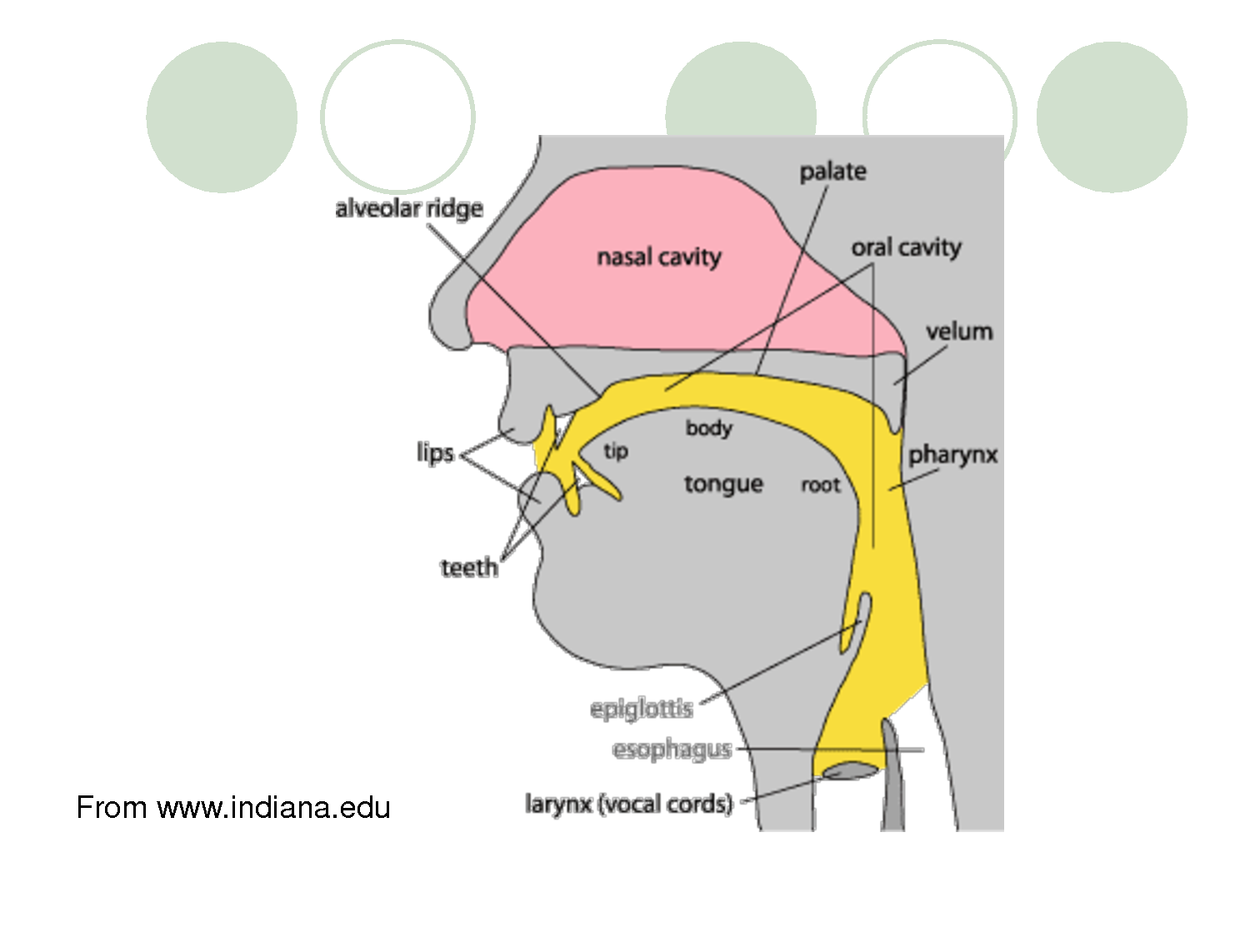

|  |  |  |  |  |  |  |
| --- | --- | --- | --- | --- | --- | --- |
| **Place of articulation** | **Manner of articulation** | | | | | |
| **Plosive** | **Fricative** | **Affricate** | **Nasal** | **Lateral** | **Approximant** |
| **Bilabial** | pen /pɛn/  bay /beɪ/ |  |  | mouth /maʊθ/ |  | why /waɪ/ |
| **Labiodental** |  | fan /fæn/  van /væn/ |  |  |  |  |
| **Dental** |  | thin /θɪn/  the /ðə/ |  |  |  |  |
| **Alveolar** | ten /ten/  door /dɔː/ | sun /sʌn/  zoo /zuː/ |  | nose /nəʊz/ | low /ləʊ/ |  |
| **Palato-alveolar** |  | shoe /ʃuː/  vision /ˈvɪʒən/ | chip /ʧɪp/  gene /ʤiːn/ |  |  | run /rʌn/ |
| **Palatal** |  |  |  |  |  | you /juː/ |
| **Velar** | key /kiː/  girl /gɜːl/ |  |  | ring /rɪŋ/ |  |  |
| **Glottal** |  | **h**at /hæt/ |  |  |  |  |

/p/: unvoiced consonant /b/: voiced consonant /h/: non-paired consonant